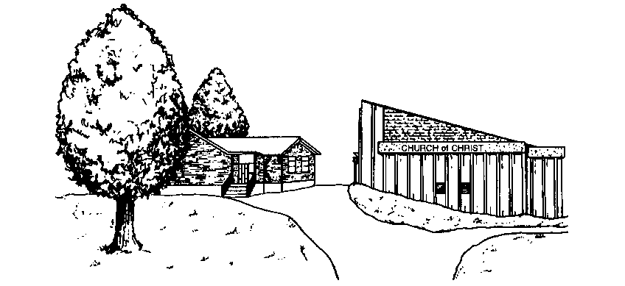

39th Street Church of Christ
15331 East 39th Street
Independence, Missouri 64055-4240
(816) 373-4946

